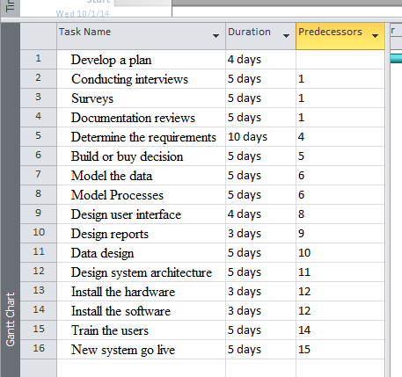

- Using the task list above, create a Gantt chart using GanttProject (www.ganttproject.biz).
- Create a PERT chart based on the task list.
  - How is the PERT chart different from the Gantt chart?
  - What advantages or disadvantages do you see in each?
  - Which do you prefer and why?
- Identify the critical path for the project.
- Explain how the critical path is determined.
- How will you use the critical path as the project manager?

